County of Henrico

Hazard Communication Program



Department of (Insert)

Date: ________________________

Hazard Communication Program

Table of Contents

- Objective
- Responsibility
- Program
- Hazardous Chemicals Inventory List
- Safety Data Sheets
- Labeling and Pictograms
- Training
- Storage
- Non-Routine Tasks
- Program Compliance
- Attachments
- Acknowledgement of HC Training
- Hazardous Chemicals Inventory List
- Globally Harmonized System Pictograms and Hazards
- Training Roster
- Sample Label
- Sections on a Safety Data Sheet
- Annual Review Documentation

Henrico County

Department of

Hazard Communication Program
- Objective
This written Hazard Communication Program (HCP) is designed to help ensure all County of Henrico departments comply with the Virginia Occupational Safety & Health (VOSH) Standard 29 CFR 1910.1200. This standard helps to ensure the safety and well-being of all (Department) employees who use hazardous chemicals during their assigned work hours.
II. Responsibility
(Responsible Person Name) is the Hazard Communication Program Administrator. He/she is responsible for ensuring this program is completed, maintained and that all affected employees have been properly trained. (An alternate or back-up Hazard Communication Program Administrator should be assigned in case the primary person is not available.)
III. Program
Completing all components of the HCP will help to ensure compliance with the VOSH HC Standard, as well as help to make the work environment as safe as possible for all affected employees.
- Hazardous Chemical Inventory List—Attachment B
A list of the hazardous chemicals used for work activities in (Dept.) will be maintained and updated by (Responsible Person Name) . This inventory list will include all chemicals or materials that require a Safety Data Sheet (SDS).
This inventory list will be kept in the front of each SDS notebook or database or electronic file. Other copies may be filed with the department head or with the Hazard Communication Officer. For each chemical used in the workplace, an SDS must be available to all employees at all times.
- Safety Data Sheets (SDSs)—Attachment F

The Hazard Communication Program Administrator (Responsible Person Name) will keep all SDSs organized and will store or file them in (identified and accessible location) for employees to review at will. The Office of Emergency Management and Workplace Safety (EMWS) recommends that a complete duplicate set of SDSs be maintained by the alternate Hazard Communication Officer or the Department.
SDS notebooks and the Hazardous Chemical inventory List will be maintained and kept up to date by (Responsible Person Name) . As outdated SDSs are replaced by updated versions, the old version will be retained for 30 years. This is because the SDS information is considered an employee exposure record. [29 CFR 1910.1020(d)(1)(ii)(B)]. Only the hazardous substance and the manufacturer shall be retained in departmental records.
The Hazard Communication Program Administrator, will verify at least annually that the department’s SDSs correctly reflect chemical reformulations, improvements, or updates.
If a hazardous chemical or substance is received without a proper SDS, the receiving person will immediately notify the Hazard Communication Program Administrator. He/she or a designee, will immediately contact the manufacturer or distributor of the product. If the manufacturer or distributor is unable to produce an SDS, the Hazard Communication Program Administrator will return the product to the supplier.
- Labeling and Pictograms—Attachments C and E
Each container of a hazardous chemical must be labeled with the identity of the hazardous material, the appropriate hazard warnings, Globally Harmonized System pictogram(s), signal word(s), and the name and address of the manufacturer. Appropriate labels must be on all containers, regardless of size or origin. Containers must be approved and recommended for storage and/or dispensing of the particular hazardous chemicals contained in them.
Worn, torn or illegible labels must be replaced. It is the responsibility of employees to report inappropriate labels to the supervisor. It is the responsibility of the Hazard Communication Program Administrator to ensure that appropriate labels are in place and that replacement labels are available. Handwritten labels comply with the standard. All labels must be in English, but alternate languages may be used in addition to English.
Portable or secondary containers of hazardous chemicals or materials do not require labeling if the chemicals or materials are transferred from primary container for immediate use by the employee who performs the transfer. The secondary container must be kept under the supervision of the same employee for the duration of the work shift. Portable containers not immediately used will be emptied (and cleaned when necessary) within (insert time) hours, no greater than a work shift.
- Training—Attachments A and D
All full- and part-time employees of (Department) shall be trained upon initial hire on the following:
- label elements;
- globally harmonized system pictograms;
- SDS format to ensure understanding of the product, its required personal protective equipment (PPE), and any first aid requirements;
- the chemicals they will be exposed to;
- locations of SDSs; and
- any chemicals in supply lines within or near their work location.
(Note: If required, Department of Transportation (DOT) pictograms and identification placards should also be included in this training.)
Each affected employee working for (Department) is required to complete the training material using Webnet or other equally effective training. Departments are responsible for recording all employee training. Employees will receive training on any new hazardous chemical/material introduced into the workplace before the chemical/material is used or when changes are made to the program.

E. Storage
All storage areas for hazardous chemicals and substances will be secured, properly ventilated, and identified by appropriate identity and hazard warning signage.

F. Non-Routine Tasks
Before any non-routine task is performed, all affected employees shall be advised, and/or they must contact (Responsible Person) to be informed of any necessary special precautions. (Responsible Person) shall inform any other personnel near the work area who might be affected by the tasks.
If a non-routine task is necessary, (Responsible Person) will provide the affected employees with information about the activity as it relates to the specific chemicals expected to be encountered:
- specific chemical name(s) and hazard(s);
- personal protective equipment required and safety measures to be taken;
- measures that have been taken to lessen the hazards including ventilation, respirators; and
- emergency procedures.
(Responsible Person) will contact all contractors before work starts to gather and disseminate any information concerning chemical hazards the contractor is bringing into the workplace.
G. Program Compliance
The Hazard Communication Program Administrator, an appointed alternate, and/or any other responsible person, is responsible for ensuring that the County of Henrico has complied with all components of the Hazard Communication Standard (29 CFR 1910.1200).
For assistance or questions, contact the Office of EMWS at 804-501-5661.

ATTACHMENT A

Acknowledgement of HC Training

(other than Webnet)

My signature below acknowledges I have received training for the Hazard Communication Standard. I understand that this training fulfills the employee training requirement of the VOSH Standard, which is 29 CFR 1910.1200.
The training included the following:
- Understanding the purpose and scope of the VOSH Hazard Communication Standard.
- Explanation of the existence of federal, state and local right-to-know laws.
- Definition of the classification “hazardous chemical.”
- Explanation of situations and elements that must be present for a material to be considered a health hazard.
- Explanation and interpretation of labels, what is required on all containers, and how to read and understand all warning labels and symbols.
- Understanding and interpretation of Safety Data Sheets and pictogram(s).
- My responsibilities as an employee of (Department) .
- Policies and procedures to follow in case of exposure and/or clean-ups.
Employee Signature
Date of Training
ATTACHMENT B

Hazardous Chemicals Inventory List

List Updated: _______________________

DATE RECEIVED | PRODUCT  NAME | HAZARD WARNINGS AND LABELING | EXPIRATION DATE,  IF ANY | SAFETY DATA SHEET
EX. 02/02/17 | A-1 Chlorine Bleach | Corrosive, Irritant | n/a | On file in notebook.

Attachment C
Globally Harmonized System

Pictograms and Hazards
HEALTH HAZARD  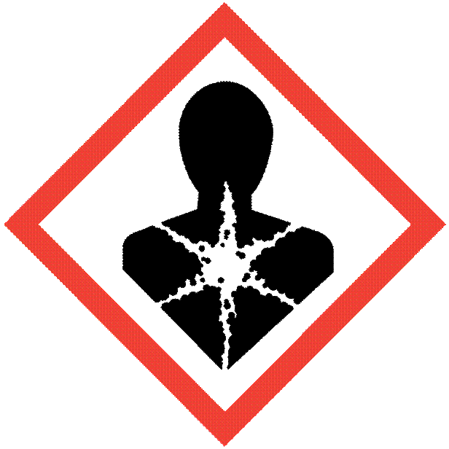 | 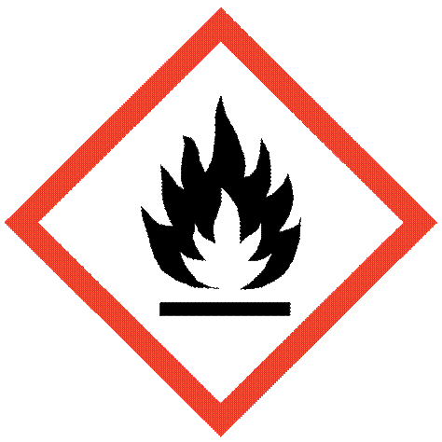  FLAME |   GAS CYLINDER
Carcinogen  Mutagenicity  Reproductive Toxicity  Respiratory Sensitizer Target Organ Toxicity  Aspiration Toxicity | Flammable  Pyrophorics  Self-Heating  Emits Flammable Gas  Self-Peroxides | Gases Under Pressure
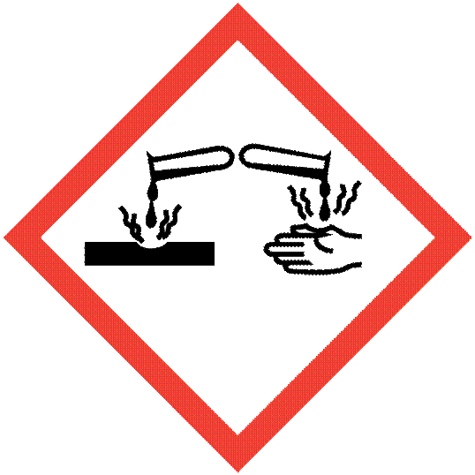  CORROSION |   EXCLAMATION MARK* | 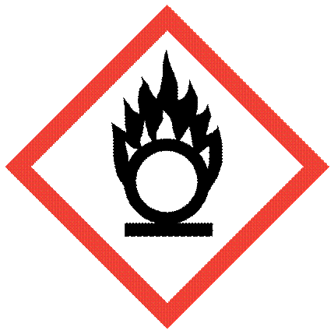  FLAME OVER CIRCLE
Skin Corrosion/Burns  Eye Damage  Corrosive to Metals | Irritant (skin and eye)  Skin Sensitizer  Acute Toxicity  Narcotic Effects  Respiratory Tract Irritant  Hazardous to Ozone Layer  *(Non-Mandatory) | Oxidizers

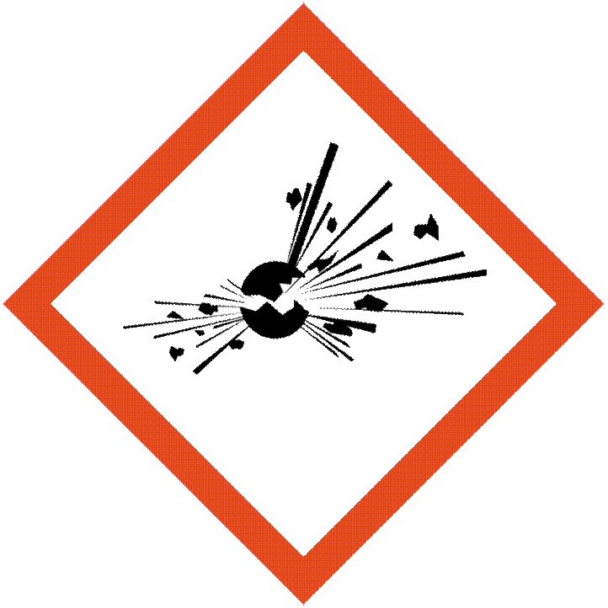  Exploding Bomb | 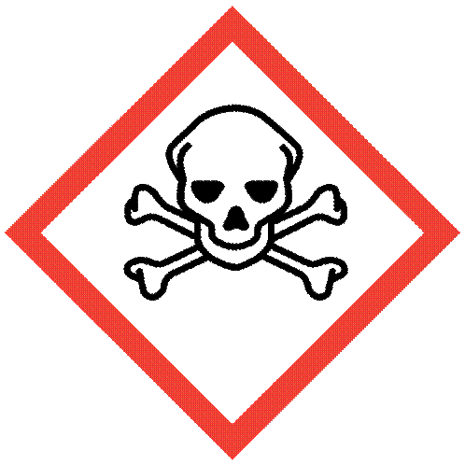  Skull and Crossbones | 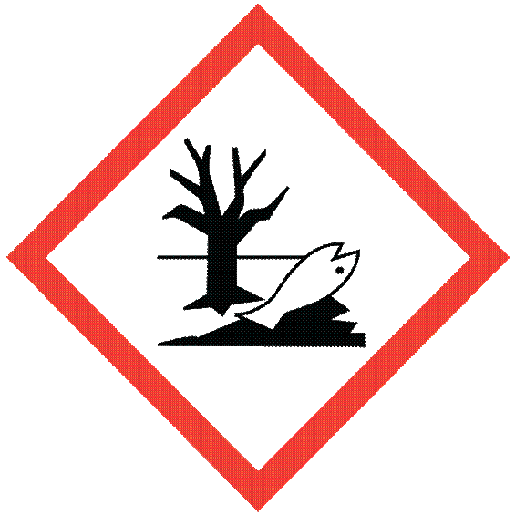  Environment*
Explosives  Self-Reactives  Organic Peroxides | Acute Toxicity (fatal or toxic) | Aquatic Toxicity  *(Non-Mandatory)

Attachment D

Training Roster
Date of Training: __________________________________
Items covered: ____________________________________
Instructor: _______________________________________
Print name, sign and date:
____________________________________________________________________________________________________________________________________________________________________________________________________________________________________________________________________________________________________________________________________________________________________________________________________________________________________________________________________________________________________________________________________________________________________________________________________________________________________________________________________________________________________________________________________________________________________________________________________________________________________________________________________________________________________________________________________________________________________________________________________________________________________________________________________________________________________________________________________________________________________________________________________________________________________________________________________________________________________________________________________________________________________________________________________________________________________________________________________________________________________________________________________________________________________________________________________________________________________________________________________________________________________________________________________________________________________________________

Attachment E

Sample Label

Product Identifier
CODE
Product Name
_Supplier Identification
Company Name_
Street Address _
City _________________ State _
Postal Code __________ Country
Emergency Phone Number ___________
Precautionary Statements
Keep container tightly closed. Store in cool, well ventilated place that is locked.
Keep away from heat/sparks/open flame. No smoking.
Only use non-sparking tools.
Use explosion-proof electrical equipment.
Take precautionary measure against static discharge.
Ground and bond container and receiving equipment.
Do not breathe vapors.
Wear protective gloves.
Do not eat, drink or smoke when using this product.
Wash hands thoroughly after handling.
Dispose of in accordance with local, regional, national, international regulations as specified.
In Case of Fire: use dry chemical (BC) or carbon dioxide (CO₂) fire extinguisher to extinguish.
First Aid
If exposed call Poison Center.
If on skin (on hair): Take off immediately any contaminated clothing. Rinse skin with water.

Hazard Pictograms


Signal Word

Danger

Hazard Statement
Highly flammable liquid and vapor.
May cause liver and kidney damage.

Supplemental Information
Directions for use
Fill weight: _____________ Lot Number
Gross weight: __________ Fill Date:
Expiration Date:

Attachment F
SECTIONS ON A SAFETY DATA SHEET
The Hazard Communication Standard (HCS) requires chemical manufacturers, distributors, or importers to provide Safety Data Sheets (SDSs) (formerly known as Material Safety Data Sheets or MSDSs) to communicate the hazards of chemical products. As of June 1, 2015, the HCS will require new SDSs to be in a uniform format that must include the section numbers, headings, and associated information listed below:

Section 1, Identification
Includes product identifier; manufacturer or distributor name, address, phone number; emergency phone number; recommended use; and restrictions on use.
Section 2, Hazard(s) identification
Includes all hazards regarding the chemical and required label elements.
Section 3, Composition/information on ingredients
Includes information on chemical ingredients and trade secret claims.
Section 4, First-aid measures
Includes important symptoms/effects, including acute or delayed and required treatment.
Section 5, Fire-fighting measures
Lists suitable extinguishing techniques and equipment and chemical hazards from fire.
Section 6, Accidental release measures
Lists emergency procedures; protective equipment; proper methods of containment; and cleanup.

Section 7, Handling and storage
Lists precautions for safe handling and storage, including incompatibilities.
Section 8, Exposure controls/personal protection Lists OSHA’s Permissible Exposure Limits (PELs); Threshold Limit Values (TLVs); appropriate engineering controls; and personal protective equipment.
Section 9, Physical and chemical properties
Lists the chemical’s characteristics.
Section 10, Stability and reactivity
Lists chemical stability and possibility
of hazardous reactions.
Section 11, Toxicological information
Includes routes of exposure; related symptoms including acute and chronic effects; and numerical measures of toxicity.
Section 12, Ecological information*
Section 13, Disposal considerations*
Section 14, Transport information*
Section 15, Regulatory information*
Section 16, Other information
Includes the date of preparation or last revision.

Employers must ensure that SDSs are readily accessible to employees.
See Appendix D of 29 CFR 1910.1200 for a detailed description of SDS contents.
*Note: Since other agencies regulate this information, OSHA will not be enforcing Sections 12 through 15 of 29 CFR 1910.1200(g)(2).

Attachment G
Annual Review Documentation

The Hazard Communication Program for the Department of _____________ , Division __________has had an annual review. This review includes any necessary updates to the Hazardous Chemicals Inventory List, the current Safety Data Sheets, and training for employees when hazards or conditions have changed since the last review (i.e., new hazardous chemicals or work process have been implemented since the last review.

Date of Review: ___________________________

Name of Reviewer (print): _________________________________

Signature of Reviewer: ____________________________________

Title of Reviewer: ___________________________________

